PICTURE PIECES!
Father’s Music Background
Nationality: Iran
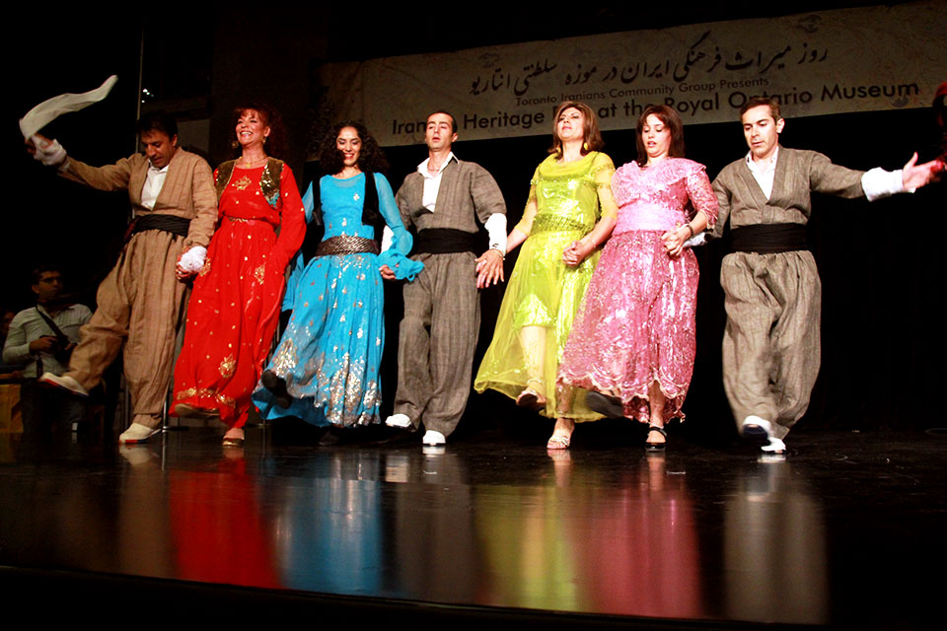
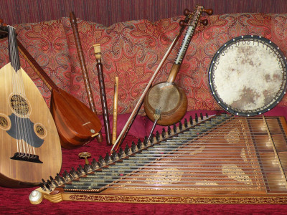
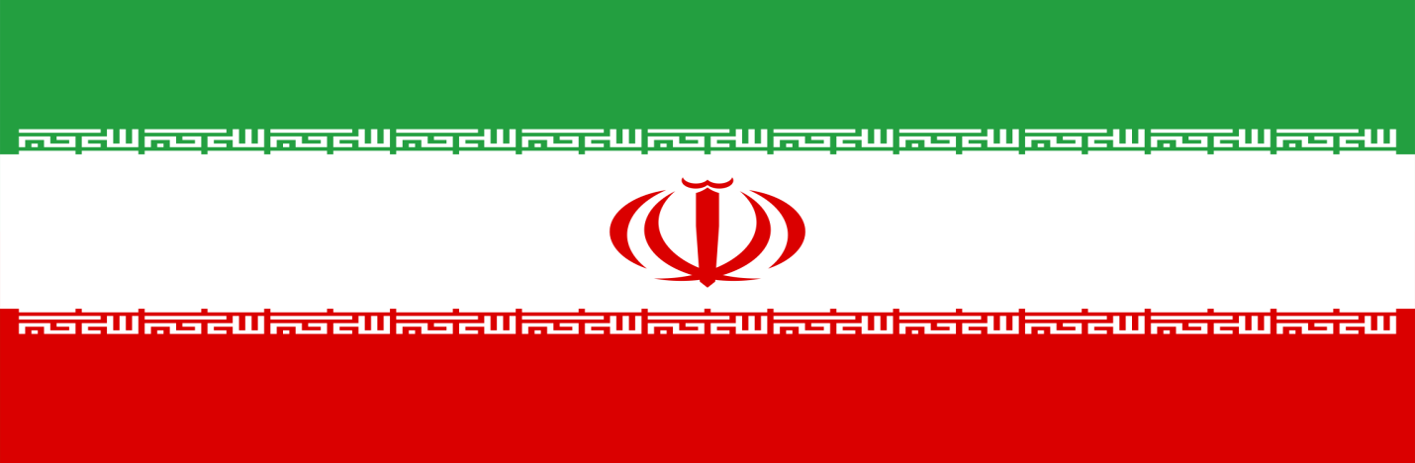
Kurdish people that live in Turkey, Azerbaijan and Iran have more than 29 kinds of dances each with particular instrumentation and rhythmic movements. I learned a few dances by my father, one named “Sheikhani” which introduces skipping movements amongst the individuals while crossing your feet. Another dance song the “Sepaz” is a bit easier to learn and only results in two –three steps. There is no crossing of the feet in the “Sepaz”. Lots of the songs my father knows are from weddings and village celebration ceremonies. Kurdish people tend to follow the off-beat more often than the main beat, because most of their dances have a lot of syncopation. The instrumentation used in my father’s music is very different then what we use in today’s western culture. A drum known as the “Tabre” beats out the main pulse of certain performances. The rhythm changes from duple to triple meters at some parts, which is seen especially in the “Sheikhani”. The “Na-ye” is a woodwind instrument that is always used in Iranian music. The shape of this instrument is a recorder look alike, but has a reed sticking out from the top instead of a wooden mouthpiece. It is usually played in the intro and middle parts for wedding dances.
LINK TO KURDISH MUSIC DANCE: https://www.youtube.com/watch?v=F5uGpymoAj4
Mother’s Music Background
Nationality: Poland
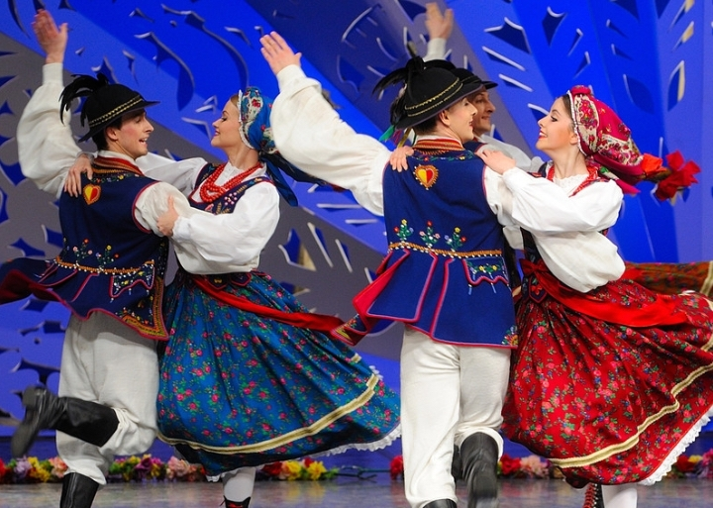
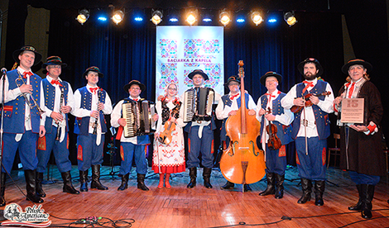
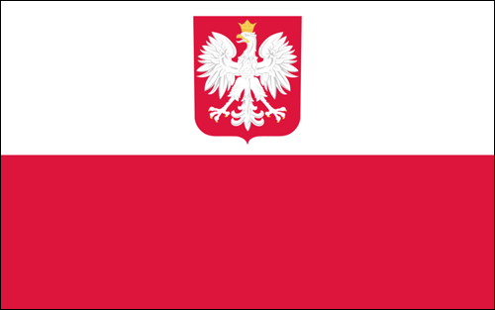
Like my father, my mother never played an instrument, but she did dance. The polish folk dance allowed different partners to socialize amongst one another. The age of most dancers in the polish folk dance was 16-23. It was meant for boys and girls to meet one another. Keeping culture is very important amongst polish people, which is why we still have polish folk dances today. I took polish school here in London, and in the curriculum we had to partner up with the opposite gender and dance to a particular polish folk tune. My mother had to do the exact same thing when she lived in Europe. Each dance is performed by couples that wear very extravagant clothing that represents their region in the country and is also stylized to highlight Poland’s national animal the bald eagle. Some of the main dances are called Kujawiak, Oberek, and Krakowiak. There is not one set rhythm from start to finish in any of these dances. The meter can change from 2/4 to 3/4 to 5/4. This can get very confusing when trying to learn certain steps. The “Oberek” is known for its starts and stops, as well as its accelerating rhythmic changes. The instrumentation consists of fiddles/sukas, a double bass, bagpipes, and the tambourine.
LINK TO POLISH DANCE: https://www.youtube.com/watch?v=TKQe9x-10yM

MY MUSICAL SELF
After I finish all my instrument classes here at Western University I will be able to play almost every woodwind, brass, strings and percussion instrument there is. My three main instruments are the Piano, Viola, and Saxophone. I enjoy all genres of music but I listen to particular songs for certain things that I do. Pieces that relax me tend to be in the jazz part of music. Louis Armstrong is one of my favourite people to listen to. A couple of my favourite songs that he is in are Summertime and Dream A Little Dream Of Me. When I am at the gym I listen to more upbeat dance music with a drop. Good Things by Radistai DJs ft. Beatrich and Whole Heart (BKAYE Remix) by Gryffin are songs pieces that motivate me to get up and workout. The person that got me into music was my Grade 5 music teacher Mrs. Case at Lester B. Pearson School for the Arts here in London where I picked up the Viola. After my primary school years at Pearson, I had the privilege to learn under Mr. Imraan Haq who is currently the strings teacher over at my old high school London Central Secondary School. He really motivated my path of hopefully one day becoming a music educator just like him. While I was at Central I had private lessons outside of school with Ralph Aldrich who was and still is a well known teacher and professor around the world. My first instrument though was not the viola, but the piano where I won many awards and scholarships from the Kiwanis Music Festival. One scholarship really stuck with me to this day and it was the National Music Camp Scholarship. This allowed me to be a camper in my very first music camp setting. I loved it so much that I wanted to work there and so I have been with the National Music Camp for over five years and am currently a music staff member attending the camp in Orillia every summer. I think that music is very important in an individual’s life because it reduces stress and brings out happiness, relaxation and is a brilliant way of expressing to others how you feel.

